**CCIERants Phone Control Install Guide for my awesome Alpha/Beta Testers ☺ (Updated Version 0.5, Scroll down to the last section if you want to hear about the call recording)**

Hi Guys I super appreciate you helping me out.

Please report any issues you encounter to the facebook group: <https://www.facebook.com/groups/506900606132711/> that way it is one common location for them all bugs.

I am keen on any performance bugs you encounter, any incompatibilities (this has been tested with a 7945 mostly and it has gone fine so keen to see what happens with other phone models)

**Please note the screenshot update is not real time and this isn’t my fault (at least not this time)** the problem is that the phone itself doesn’t update the screenshot image file very often, only about once every 500 ms or something, so the screenshot will ALWAYS lag a little bit behind.

The app uses web access, so you must have web access to the phone and IP connectivity to it, you can verify this by browsing to the phones IP address:

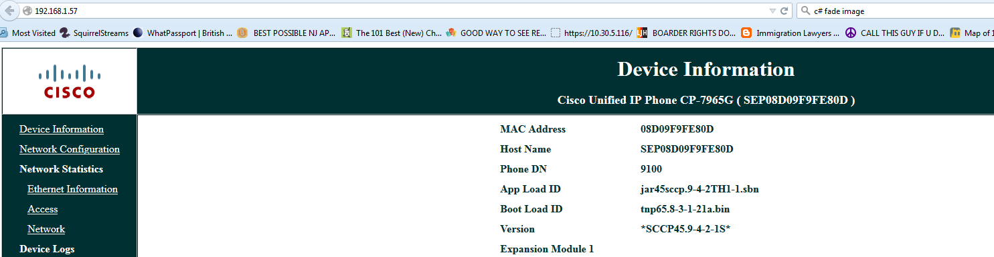

Right now the app uses HTTP, so you need to use http, so just http://<ip-of-your-phone>/ to test ☺

Now, if you can’t browse to the webpage of the phone, you need to enable web access, login to CUCM then navigate to your phone and scroll down until you see this (or search for it):



And:



You have also got to assign a user this phone, they must have the phone you want to control listed as a controlled device:

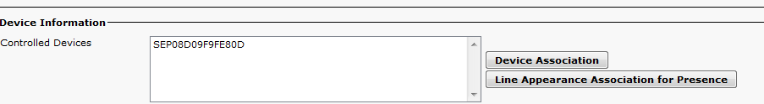

This should be a normal user, I just used “peter” and “peter” as the password for example ha ha. You can assign multiple devices to the same user and keep using the same user that is perfectly fine. User doesn’t need “Allow control of device via CTI” or anything like that.

The app currently tries to get a screenshot per second, this uses about 500kbps to 1 megabit per second of bandwidth so not TOO bad but maybe too high for some locations.

OK, how to use app:

When you first start it, it will look like this:

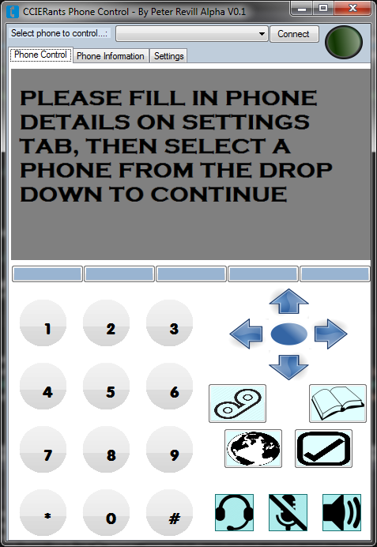

Click on the settings tab and fill in your phone details.

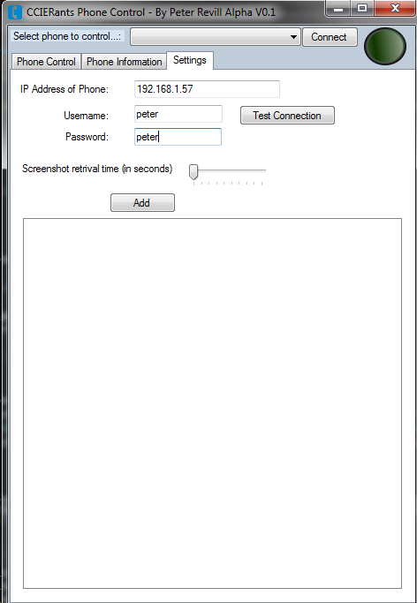

The timer is between 1 second to 10 seconds, you can test the connection or just add the phone, adding the phone will test the connection at the same time.

Once this is done, you need to select the phone from the dropdown box at the top then click Connect

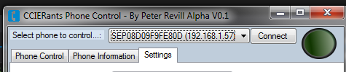

Once you click connect if it is successful the green light will glow and you are good to go!

Click on the “phone information” tab and select from the drop down box to see call streaming stats, log messages, stuff like that, this is updated every time you change the dropbox selection (if you reckon it needs to be on a timer to update, let me know and I’ll try and implement it!)

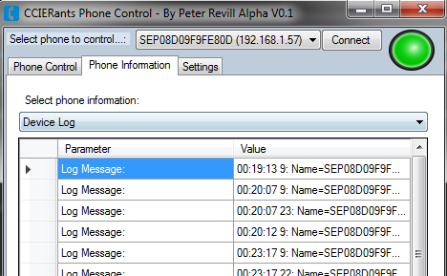

If you want to view the log message in full, just double click on the cell (so for example, above you would click on the value cell that says “00:19:13” you have got to double click it ☺

It will pop up the message in a separate window:

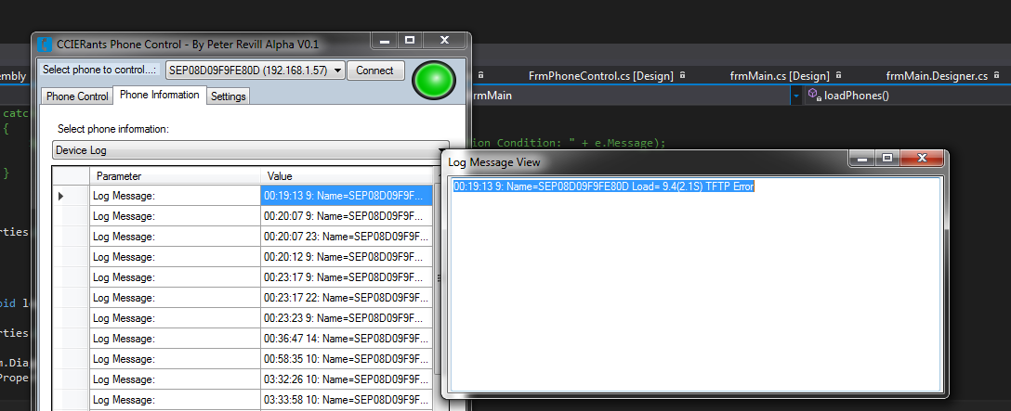

If you encounter any issues, please upload the “LoggingFile-Give-To-Peter.txt” file that should be in the same directory as the application.exe ☺

That should be it! Have fun and THANKS AGAIN! ☺

**CALL RECORDING SETUP**

Hey Guys

So the call recording has two different methods. The first is basic mode which just sends a simple XML msg to the phones, the problem is it’s ONE WAY only, you can only hear the sound made by the person on the end of the phone, not who THEY are talking to ☹. But this just works out of the box you don’t have to do anything, read on for advanced mode.

In advanced mode, you can hear both parties, Wippie!

Unfortunately, it’s a shitload of work to set it up ☹.

You need to create a SIP Trunk that points to your IP address of whatever device your running the phone controller on, and that’s where you select the listener IP ☺.

You can create the SIP Trunk pretty half-assed, you just need to fill in these bits:

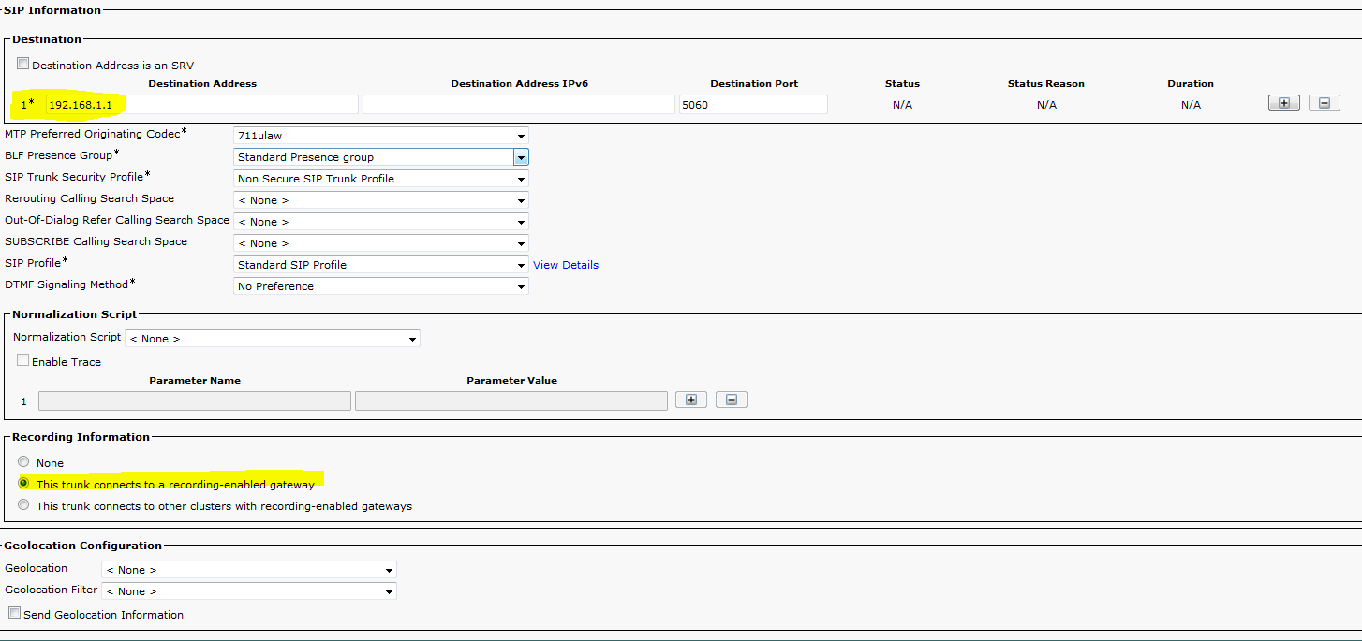  
Once that is done, you just need to create a single route pattern for any number that fits into your dial plan (which should be E.164, if it isn’t, why the heck not :p Paul and me want a word with you!)

So as you can see, you just need the “This Trunk connects to a recording-enabled gateway” and an IP in the trunk, yes unfortunately this means each time you use this software on a different PC you will have to go and update the trunk: using AXL I am going to automate all of this later.

So for me it was 1100 (they use 9 for outside line here, so 1 is my system number), you can use anything.

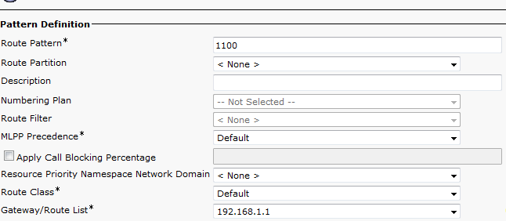

Go to Device -> Device Settings -> Recording profile and create a recording profile and set the destination address to your number, you should set a CSS If your using it obviously so that you can reach that number

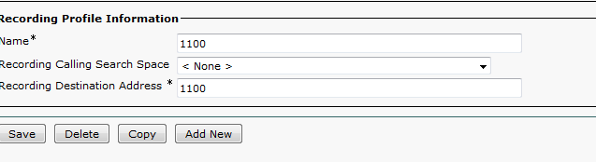

At this point you can test by dialing your number with the program in “Start listening” (advanced mode) enabled ☺.

To use this properly, just set the call recording profile under your users directory number and ensure they have call recording enabled. When I was doing this I told it to “Beep” when it was recording so I could check that it was working but obviously you might decide you don’t want to hear the beeping ☺.

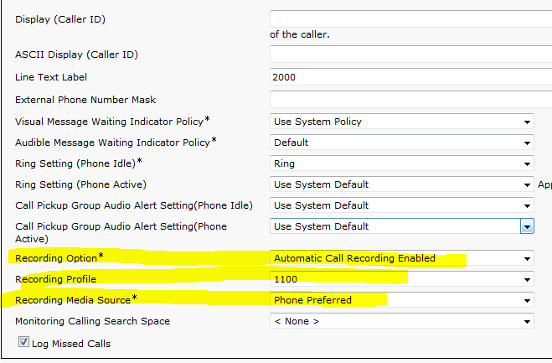

The beeping/no beeping option is found under the Device itself:

